**System Architecture**

**Project Title:**

Reinforcement Learning Futures Trading System

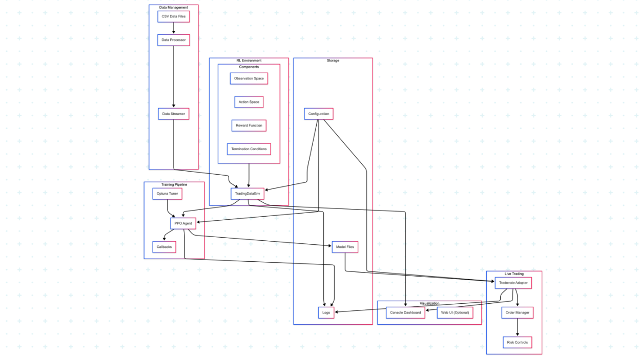

### 

### 

### 

### 

### 

### 

### 

### 

### 

### **Overview:**

### The architecture is divided into several main components, each responsible for a specific function:

* **Data Management**: Handles the ingestion and processing of raw historical price data
* **RL Environment**: Contains the core components of the RL problem formulation
* **Training Pipeline**: Manages the training process of the RL agent
* **Storage**: Serves as the central repository for various system assets
* **Live Trading**: The service responsible for executing trades in a live environment
* **Visualization**: Desktop UI

### **Data Management**

The Data Management pipeline prepares the trading data for use by the RL environment.

* **CSV Data Files**: This is the initial source of data for the system. This is historical market data with the following columns: Time, Open, High, Low, Close
* **Data Processor**: This component reads the raw CSV files and performs the necessary data cleaning, transformation, and feature engineering. It prepares the data for streaming:
  + Convert timestamps to individual trading days
  + handle missing values
  + Calculate Technical indicators
  + Calculate All Other Higher Time Frames
* **Data Streamer**: The Data Processor feeds its output into the Data Streamer. This component is responsible for providing data to the TradingDataEnv in a sequential, time-series manner, simulating a real-time data feed. This ensures the training environment receives data in the correct order, which is crucial for financial time series analysis.

**RL Environment:**

This section defines the core problem space for the reinforcement learning agent.

* **RL Environment Components**: These define the fundamental building blocks of the RL problem:
  + **Observation Space**: This defines the state an agent perceives from its environment. In this context, it is the collection of all data points and features at a given time step, including price data, technical indicators, and portfolio metrics
  + **Action Space**: This defines the set of all possible actions the agent can take. For a trading bot, this could be discrete actions like "buy," "sell," or "hold," or continuous actions representing the percentage of a portfolio to allocate.
  + **Reward Function**: This is a critical component that defines the goal of the agent. It provides a signal to the agent about the quality of its actions. A simple reward function might be the profit or loss from a trade, while a more complex one might incorporate risk-adjusted returns like the Sharpe ratio.
  + **Termination Conditions**: These define the conditions under which an episode (a single run of the simulation) ends. Examples could be reaching a specific number of trades, hitting a certain profit/loss threshold, or the end of the historical data.
* **TradingDataEnv**: This is the core environment where the RL agent interacts. It simulates the trading world. It takes the streaming data from the **Data Streamer** and uses the **RL Environment Components** to provide observations, process actions from the agent, and return rewards and the new state. This component is where the agent's actions (e.g., a "buy" signal) are translated into a simulated trade, and the reward is calculated based on the outcome

### **Training Pipeline:**

This pipeline orchestrates the training of the RL agent.

* **PPO Agent**: This is the reinforcement learning agent itself. PPO (Proximal Policy Optimization) is a popular, state-of-the-art algorithm for training agents. It learns a policy (a mapping from observations to actions) that maximizes the cumulative reward. The PPO Agent interacts with the **TradingDataEnv** to learn.
* **Optuna Tuner**: This component is a hyperparameter optimization framework, likely used to find the best configuration for the PPO agent. It automatically tests different settings (e.g., learning rate, network size) to find the ones that lead to the best performance. It directly feeds into the PPO Agent, providing the optimal hyperparameters for training.
* **Callbacks**: This component likely includes functions that are executed at specific points during training. They can be used for logging, saving model checkpoints, or early stopping, which prevents overfitting. The PPO Agent sends information to the Callbacks, which then can write to **Logs** and save **Model Files**.

### **Storage:**

Storage components act as the central repositories for various artifacts.

* **Configuration**: This component stores all the settings for the entire system, including training parameters, environment parameters, and trading rules. All other components, like the **TradingDataEnv**, **PPO Agent**, and **Live Trading** services, read from it to ensure consistent behavior.
* **Model Files**: This is where the trained models (the PPO agent's policy network) are stored. The **PPO Agent** writes to this component after a successful training run. The **Live Trading** component reads from here to get the trained model for execution.
* **Logs**: This component stores all the logs and metrics generated by the system. The **PPO Agent**, **Callbacks**, and other components write logs here. The **Console Dashboard** and **Web UI** read from here for visualization and analysis.

### **Live Trading:**

This service takes the trained agent and executes trades in a real-world, live market.

* **Tradovate Adapter**: This is a specific adapter for a brokerage or trading platform, likely Tradovate. It translates the actions from the **Order Manager** into a format that the trading platform can understand and executes the actual buy/sell orders.
* **Order Manager**: This component is the bridge between the trained model and the trading adapter. It receives actions from the PPO agent, translates them into actionable orders (e.g., "buy 10 shares of AAPL"), and sends them to the **Tradovate Adapter**. It also manages the state of the live portfolio.
* **Risk Controls**: This component is crucial for live trading. It monitors the orders and portfolio state to ensure that the agent's actions do not violate predefined risk rules. For example, it could prevent a trade if it would exceed a maximum drawdown limit or position size. The **Order Manager** and **Tradovate Adapter** both likely interact with this component to ensure safe trading.

### **Visualization:**

These components provide a window into the system's performance and behavior.

* **Console Dashboard**: A command-line interface for real-time monitoring of training progress, live trading performance, and logs. It reads directly from the **Logs** component.
* **Web UI (Optional)**: A graphical user interface that provides a more user-friendly way to visualize the same data as the console dashboard, including charts, graphs, and performance metrics. It also reads from the **Logs** component.

### **Interactions Summary**

* The **Data Streamer** provides data to the **TradingDataEnv**.
* The **TradingDataEnv** uses the **Configuration** and **RL Environment Components** to simulate the trading environment.
* The **PPO Agent** interacts with the **TradingDataEnv** to learn, sending actions and receiving observations and rewards.
* The **Optuna Tuner** optimizes the hyperparameters for the **PPO Agent**.
* The **PPO Agent** and **Callbacks** write logs to the **Logs** component and save the trained model to **Model Files**.
* The **Live Trading** service loads the trained model from **Model Files**.
* The trained model in **Live Trading** generates actions that are handled by the **Order Manager**.
* The **Order Manager** interacts with the **Risk Controls** and sends orders to the **Tradiivate Adapter**.
* The **Console Dashboard** and **Web UI** read logs from the **Logs** component to display the results.